|  |
| --- |
| Bus Route Manager  ESRI Web Solution – Technical Documentation  James Moloney 2020 |



Creative Commons information

© State of Queensland (Department of Transport and Main Roads) 2015

88x31

<http://creativecommons.org.licences/by/4.0/>

This work is licensed under a Creative Commons Attribution 4.0 Licence. You are free to copy, communicate and adapt the work, as long as you attribute the authors.  
The Queensland Government supports and encourages the dissemination and exchange of information. However, copyright protects this publication. The State of Queensland has no objection to this material being reproduced, made available online or electronically but only if its recognised as the owner of the copyright and this material remains unaltered.

|  |  |
| --- | --- |
| Interpreter_Symbol | The Queensland Government is committed to providing accessible services to Queenslanders of all cultural and linguistic backgrounds. If you have difficulty understanding this publication and need a translator, please call the Translating and Interpreting Service (TIS National) on 13 14 50 and ask them to telephone the Queensland Department of Transport and Main Roads on 13 74 68. |

Disclaimer: While every care has been taken in preparing this publication, the State of Queensland accepts no responsibility for decisions or actions taken as a result of any data, information, statement or advice, expressed or implied, contained within. To the best of our knowledge, the content was correct at the time of publishing.

Document control options

Departmental approvals

Refer to the appropriate Risk Assessment Tool for relevant reviewer and approver

|  |  |  |  |  |
| --- | --- | --- | --- | --- |
| Date | Name | Position | Action required  *(Review/endorse/approve)* | Due |
|  |  |  |  |  |
|  |  |  |  |  |

Risk level

GACC major  GACC minor  High risk (but not GACC)  Medium risk

|  |  |
| --- | --- |
| Prepared by |  |
| Title |  |
| District & Region |  |
| Branch & Division |  |
| Project/program |  |
| Project number |  |
| Project location |  |
| Status |  |
| DMS ref. no. |  |

Contents

[Background 1](#_Toc44407157)

[Bus Route Manager 2](#_Toc44407158)

[The Proof of Concept (POC) 2](#_Toc44407159)

[Components 2](#_Toc44407160)

[Feature Layers 3](#_Toc44407161)

[Print Tools 4](#_Toc44407162)

[Web Map 9](#_Toc44407163)

[Web App 9](#_Toc44407164)

[Widget 9](#_Toc44407165)

[Future Capability and Integration 11](#_Toc44407166)

[Editing & Maintaining Routes 11](#_Toc44407167)

[STIMS Integration 11](#_Toc44407168)

[STAS Integration 11](#_Toc44407169)

Table of Figures

No table of figures entries found.

Table of Tables

No table of figures entries found.

# Background

Regional operations bus contract data and maps are currently managed and produced through a MapInfo based solution called SK mapper. SK mapper has a series of map production and route management tools that allow users to graphical depict route alignments, mark up and label maps with distance calculations for the purpose of compensating regional bus operators.

It is known that the SK mapper solution is coming to "end of life" due to operating system upgrades and software compatibility issues. It has been identified by the business that there is a need to determine a way forward for managing and producing bus contract maps.

TMR have adopted the Street Pro Nav road dataset as it's default road network and all route and network information should be derived from this base dataset. This intern has triggered a data migration exercise to align the existing graphically drawn SK bus routes to a topographically correct road network.

A series of FME scripts were developed to massage the graphically drawn bus routes, captured in SK mapper to align with the Street Pro Nav road network. Then a series of data validation checks, and cleansing processes were conducted to produce bus routes populated with service, segment, link and schedule information.

It was decided, that a proof of concept (POC) solution would be developed with spare licensing that was a carryover from the completion of a recent project (STAS Smart Forms Solution). The POC was required to demonstrate the ability of displaying regional bus route data with symbology based on route information, a type ahead search capability that enabled a user to search for a route that automatically zooms and pans the map, and custom map printing functionality that produced a pdf map with associated bus contract information.

It is envisaged that future development could enabled users to maintain the bus routes and associated contract information from within the web application.

# Bus Route Manager

## The Proof of Concept (POC)

The POC Bus Route Manager is an ESRI based Solution utilising the capability of ArcGIS Server and ArcGIS Portal. This solution is comprised of a customised web app, widget and geoprocessing tools.

### Components

The components that make up the POC are

* ArcGIS Server and Portal installed on an ESRI (Amazon Web Service) AWS windows Amazon Machine Image (AMI)
* Bus Route information derived from SK mapper and data processing stored as feature layers in hosted ERSI datastore,
* Street Pro Nav road network dataset hosted as a feature layer,
* Materialised Spatial views joining bus route data to street pro nav links for searching and display,
* A base web map. (This could be further customised to include related information.)
* Customised Web App styled to TMR branding
* Custom Widget with interactive controls
* Custom Geoprocessing Print Tools

A list of the portal items

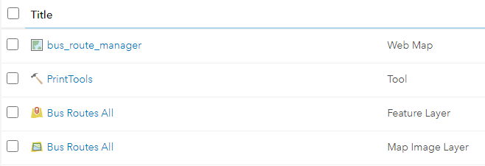

### Feature Layers

#### Schema Diagram

This diagram details the relations ships between each of the required data tables.

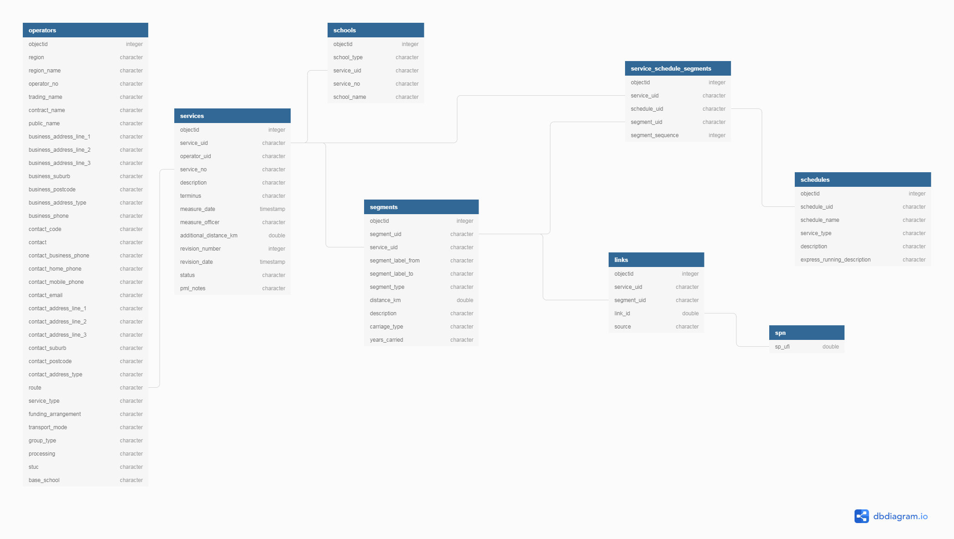

#### SPN

Street Pro Nav Data network links

#### Services

Services derived from SK Mapper Tab files using FME translations.

#### Segments using FME translations

Service Segments derived from SK Mapper Tab files using FME translations.

#### Links

Links were derived by intersecting street pro nav data with segments using FME translations.

#### Schedules

Schedules were derived from SK Mapper Data using FME translations.

#### Service Schedule Segments

This is a many to many join table to associate the service with the schedule based on what segments and the order they occur

#### Operators

This was an example table imported from a STAS extract to demonstrate how operator information that resides in STIMS could be joined to the bus route information and presented in the report export.

#### Bus Routes All View

A materialized view was created to be consumed by the web app.

This view consisted of a series of left joins to produce a flatten table for the web app to display and query data.

A materialized view was decided to improve performance and the interval at which data was updated was not real time and frequent refreshes of the materialized view would suffice in a production environment.

See appendix for view SQL

### Print Tools

Is a geoprocessing service developed in python. It has 2 tools within the geoprocessing service.

* **Get Layout Template Info** – This script requires parameter input file directory, and scans the directory for all .pagx (ArcGIS Pro Layout Files) and converts them to JSON format.
* **Export Web Map Task** – This script takes the web map as JSON that comes from the ESRI JavaScript print task and converts it to an ArcGIS Pro project in memory using the selected JSON layout file above. The script then exports the layout as a pdf to a temp directory and presents it in a new internet browser tab.

For more information on how the mechanics of a print task works see here

All python scripts are available in the TMR git repository

<https://github.com/mspatial/TMR/tree/master/esri/bus%20route%20manager/print%20tools>

#### Publishing from ArcGIS Pro

1. Open ArcGIS Pro and navigate to the print templates toolbox,

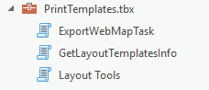

1. Run the Get Layout template info script

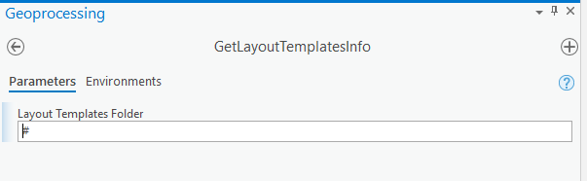

1. Run the Export Web Map Task script

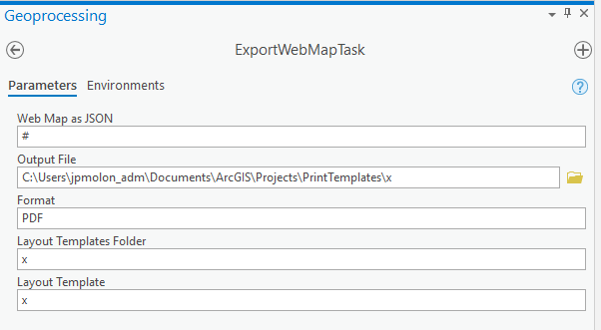

1. If both scripts were successful, go to the job history tab and right click share as a geoprocessing service.

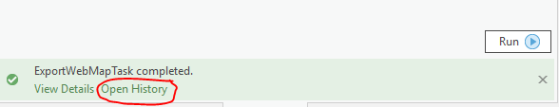

1. Add both script to the service and publish

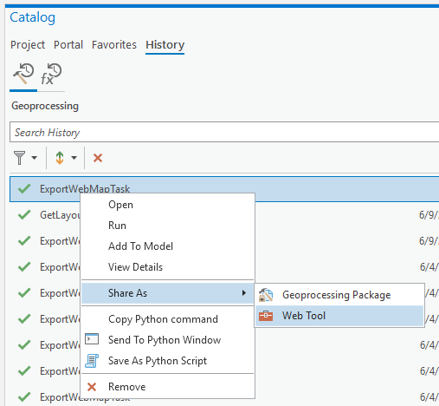

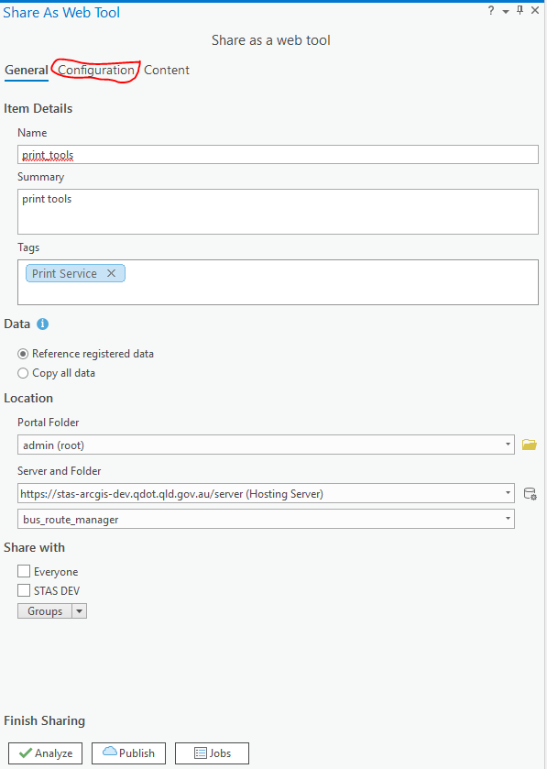 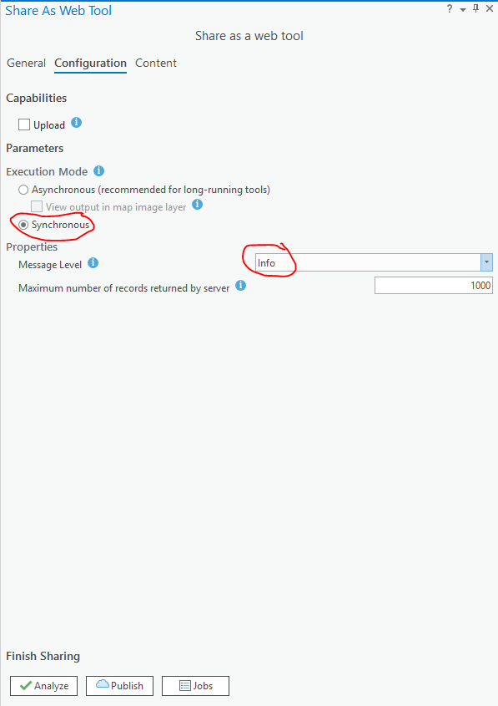

Click the add tool and select

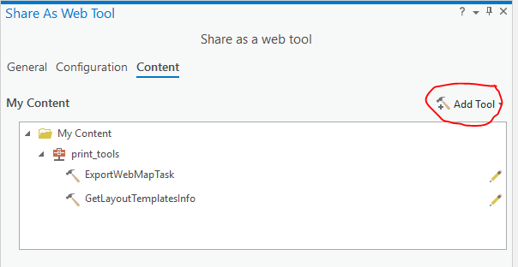

Now publish



#### Get Layout Template Info

This is the GetLayoutTemplatesInfo geoprocessing tool rest endpoint. As you can see it requires a Layout Templates Folder string parameter

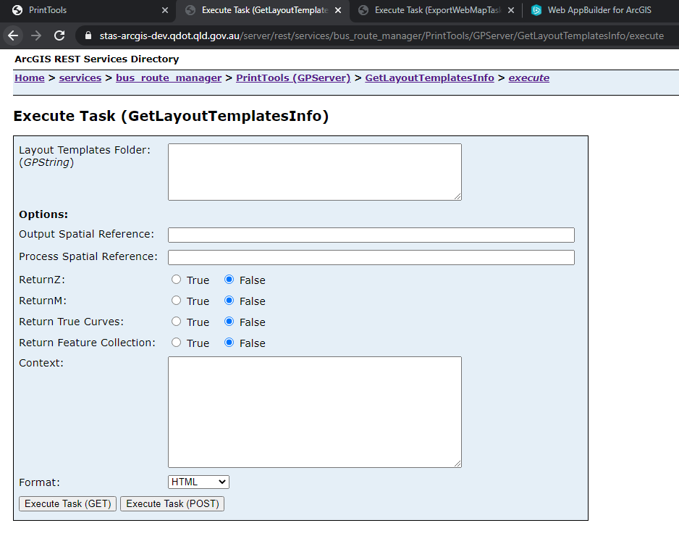

#### Export Web Map Task

This is the ExportWebMapInfoTask geoprocessing tool rest endpoint. As you can see it requires a

1. Web Map As JSON string
2. Format string - this is defaulted to PDF
3. The Layout Templates folder location string
4. The Layout template

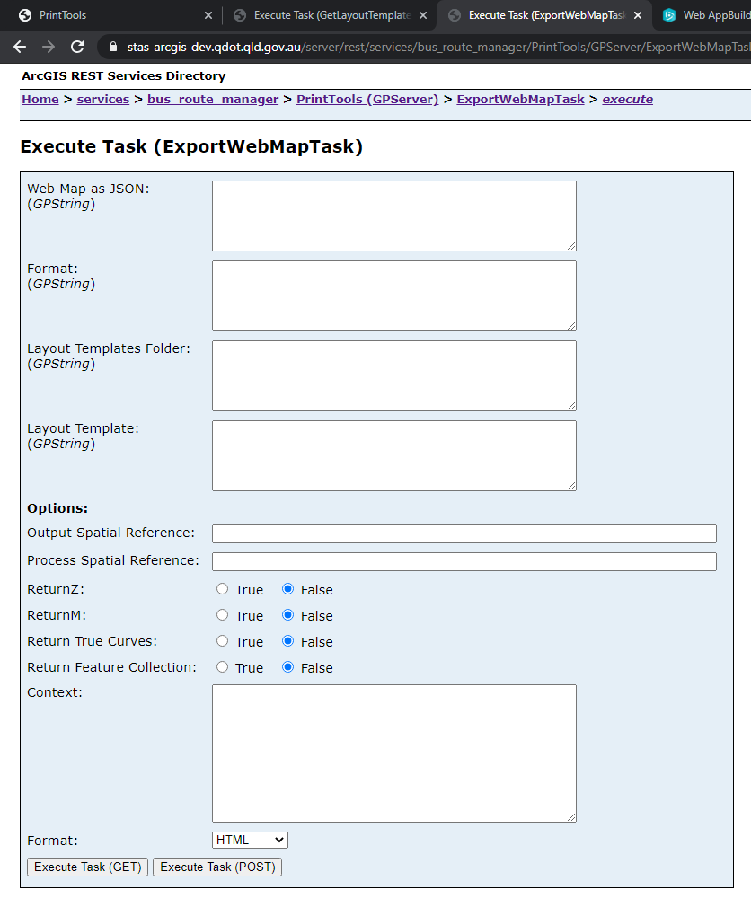

### Web Map

A basic web map was created in ArcGIS Portal and was used as the default base in the web mapping application.

It is envisaged that this web map could contain a list of relevant TMR layers for information purposes

### Web App

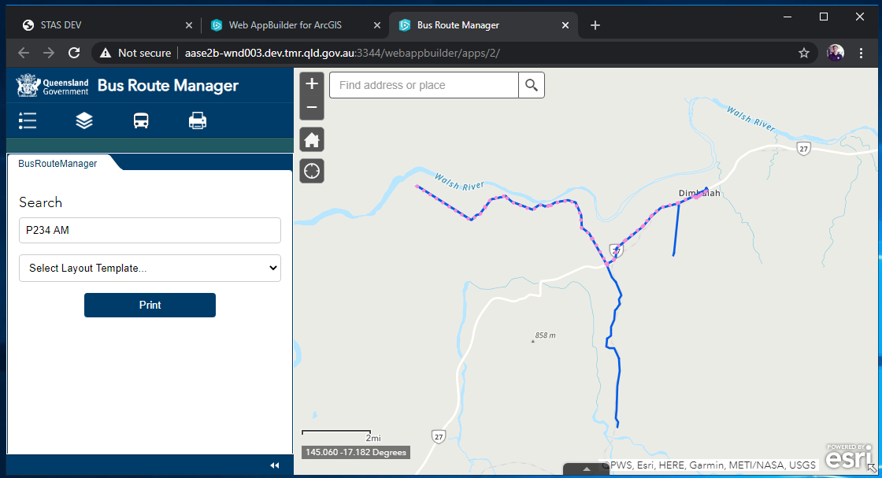

### Widget

This is a screenshot of the widget running within the Web App.

Typeahead search is activated after 3rd keystroke.

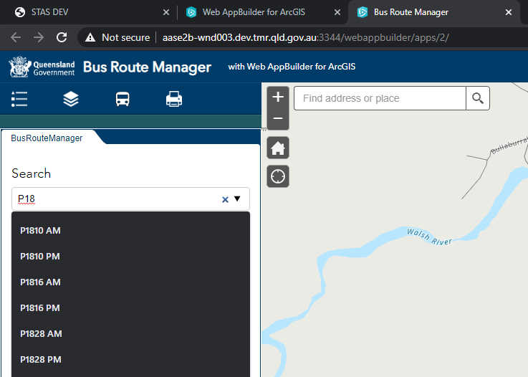

Example Printed PDF Map

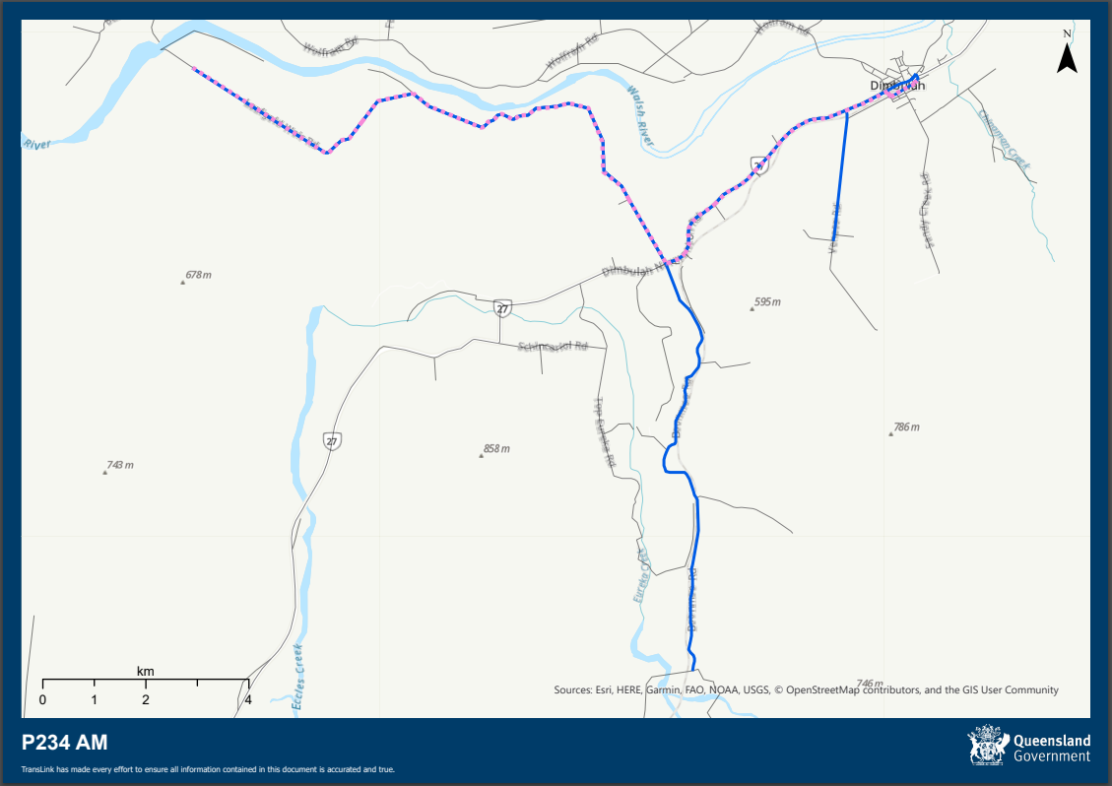

Example Printed PDF Contract Report

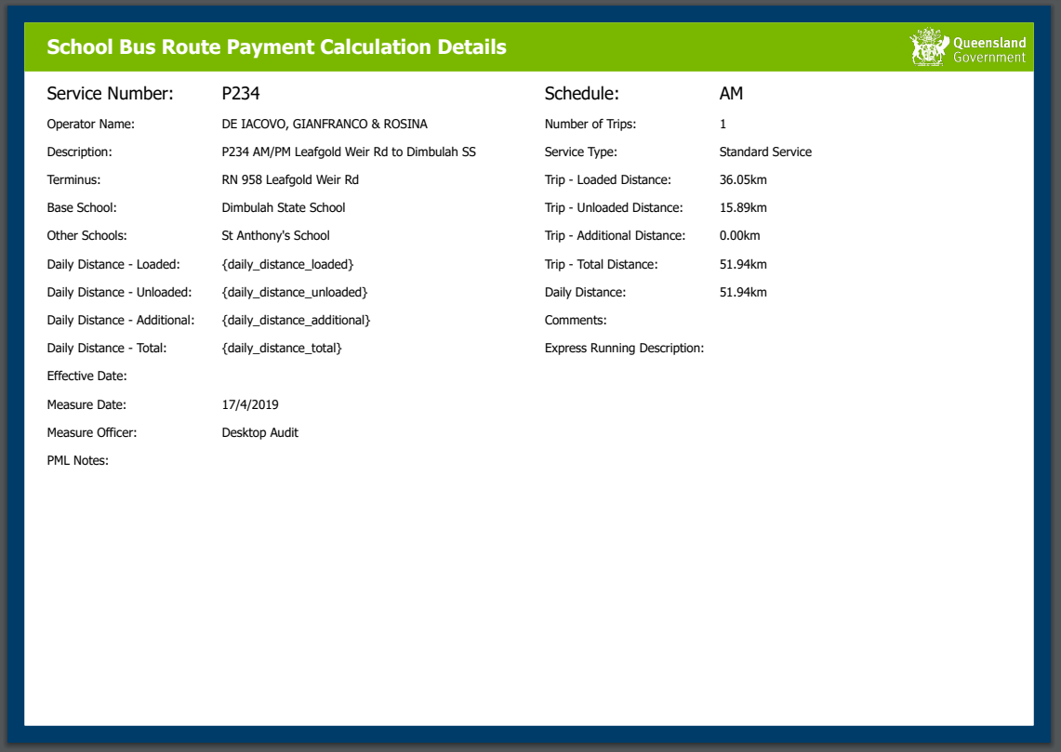

# Future Capability and Integration

## Editing & Maintaining Routes

An extended phase of this development could see a fully interactive web editing capability of the bus routes. Editing could be achieved with strict formatting and route validation to ensure the maintained routes are following the Street Pro network.

Associated contract map information could also be entered within the web application interface (for example, distance calculations, related schools, interchanges etc)

A user role and security group model could be placed on this system to ensure only the authorised users can maintain routes and related information.

An example of this capability has been demonstrated with the heavy vehicle route manager.

## STIMS Integration

Currently, bus contract maps contain information that is stored in multiple locations. These contract maps contain mark-up information that is interpreted from datastores such as STIMS. There are inherent risks with data entry and data currency when interpreting (taking a copy of) relational data in static documents. This can, over time see information become out of sync and invalid or becomes an administration overhead to ensure information is correct and up to date.

Due to the capability of web and server technologies, it is feasible for ArcGIS Server to directly communicate with external data sources such as ORACLE (where STIMS information is stored) to read information and extract it, to place in contract maps or reports. Functionality could also be developed where specific information which is best derived from the web application, could also update the STIMS database.

This approach ensures that each system maintains one source of truth and reduces the risk of inconsistent data across systems.

Possible integration solutions that could be achieved;

* Direct connection/webservice to STIMS database and join STIMS data with GIS data through a widget to present in the web app. Read and or Write operations could be assigned to specific users to maintain routes and relevant contract data.
* Create a replica and sanitized data store within the GIS database of the STIMS data using tools such as FME and Server to perform scheduled updates. This would be a one-way movement from STIMS to GIS data store. This would enable the GIS Web app to join and display relevant STIMS data in contract maps

## STAS Integration

The development of this widget is possible do to Regional Bus Routes being migrated and aligned to the Street Pro network. This not only produces a graphical representation, but a wide range of geographic and network calculations can be automated to assist in decision making.

The STAS Smart forms solution is one system that can greatly benefit from this piece of work. A detailed document has been drafted to explain how the STAS smart form technology could utilise geographic analysis with a rules-based engine to increase in efficiencies for STAS application approvals.

Please See the Regional Operations STAS GIS Documentation for detailed explanation of route integrations with STAS smart forms systems.